

- Project Title: Student Information Management System (SIMS)
- Course: Practice of Software Development Methods
- Instructor: Ali Haider
- Author: IKRAM-UL-HAQ
- Student ID: B202416010126
- Date: 31/12/2025
- University: Hubei Normal University
OVERVIEW
Student Information Management System (SIMS) is a comprehensive
Web-based application designed to automate and streamline academic
Administration processes in educational institutions.

PURPOSE
• Automate student data management
• Centralize academic information
• Improve administrative efficiency
• Provide real-time analytics

OBJECTIVES
✓ Develop working prototype in Python
✓ Implement appropriate data structures
✓ Create user-friendly interface
✓ Demonstrate software development principles
ARCHITECTURE:
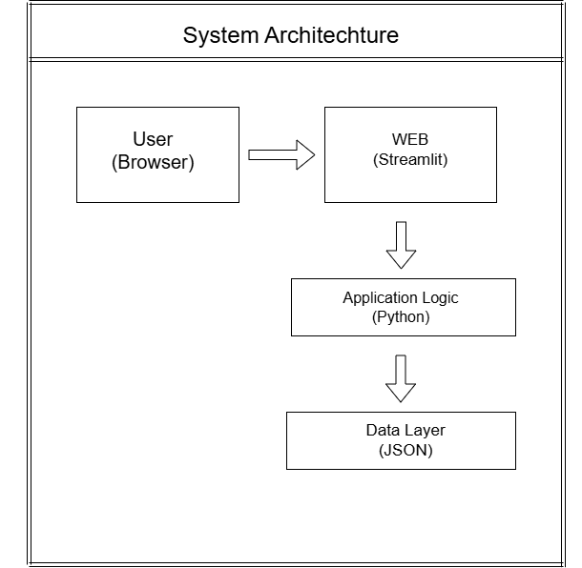
IMPLEMENTED KEY FEATURES :
✓ 1. Student Profile Management
✓ 2. Course Registration System
✓ 3. Enrollment Tracking
✓ 4. Attendance Management
✓ 5. Grade Management
✓ 6. Assignment Tracking
✓ 7. Transcript Generation
✓ 8. Timetable Scheduling
✓ 9. Performance Reports
✓ 10. Data Import/Export
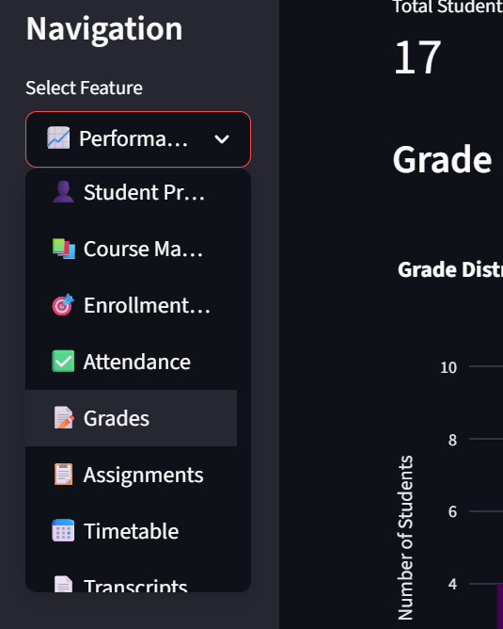
SYSTEM ARCHITECTURE:

DATA LAYER
• JSON File Storage
• Structured Data Models
• Backup System

LOGIC LAYER
• Python Core Processing
• Pandas Data Manipulation
• Business Logic Rules

GUI LAYER
• Streamlit Framework
• Interactive Web Interface
• Real-time Updates

INTERACTION FLOW
User → GUI Interface → Logic Processing → Data Storage → Results
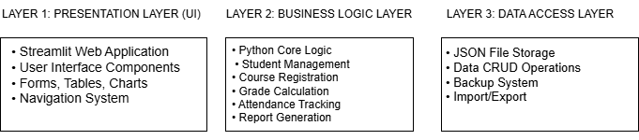
DATA STRUCTURES USED:
LISTS
• Student records storage
• Course catalog management
• Grade lists processing

DICTIONARIES
• Student ID → Details mapping
• Course information storage
• Attendance record mapping

SETS
• Unique student identification
• Course code validation
• Program categorization

TUPLES
• Fixed date information
• Grade point constants
• Time schedule data
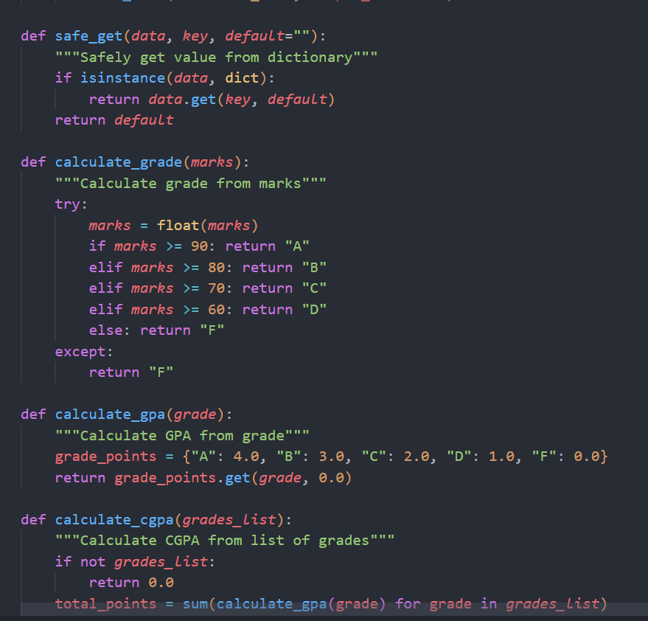

IMPLEMENTATION – CORE MODULES:

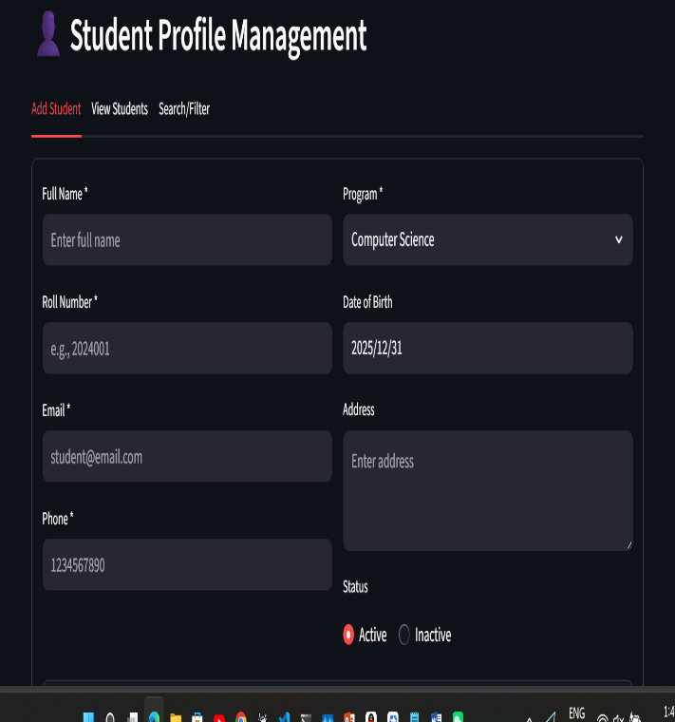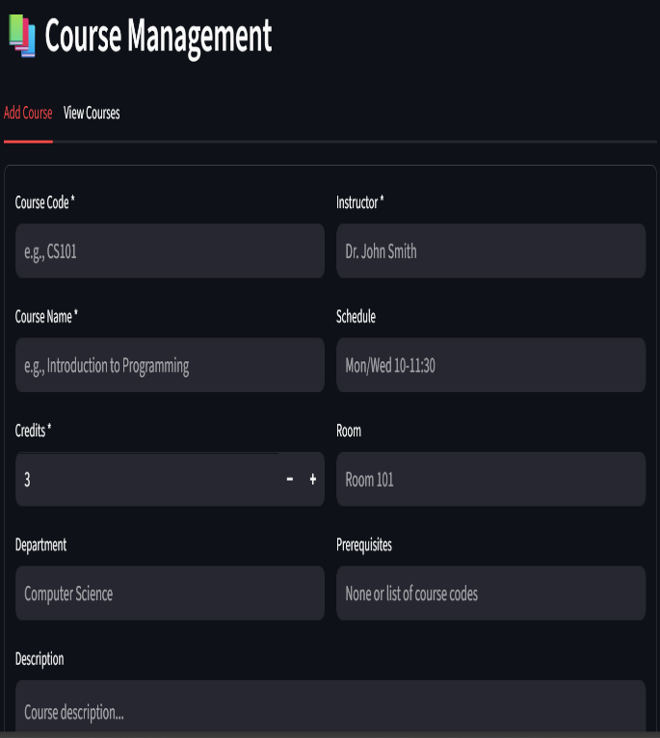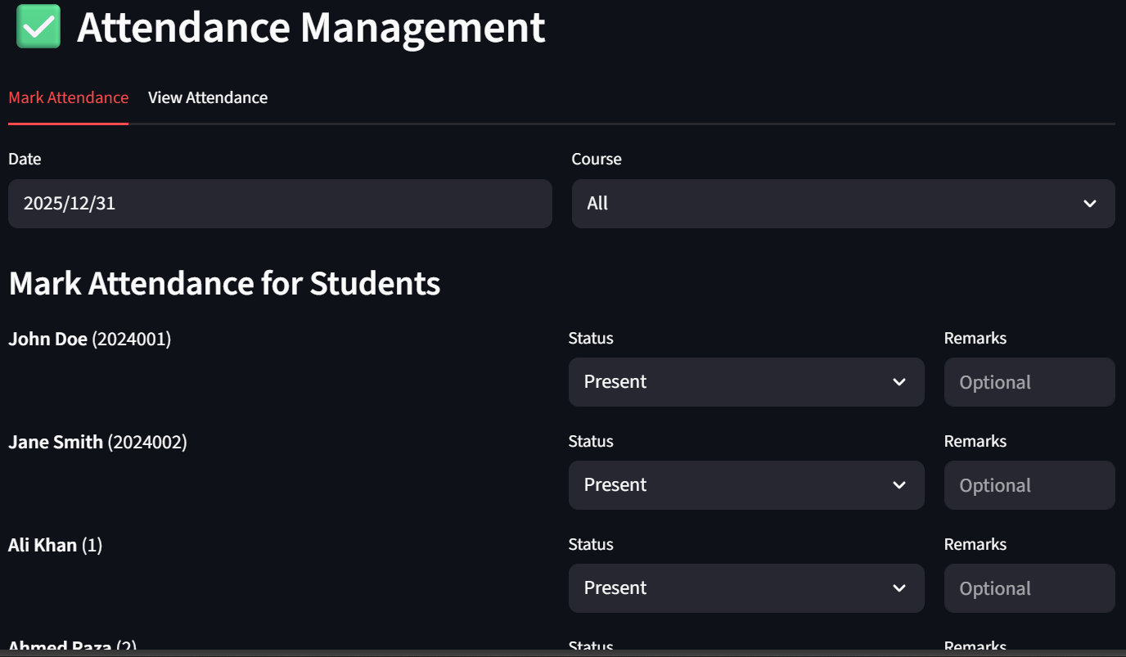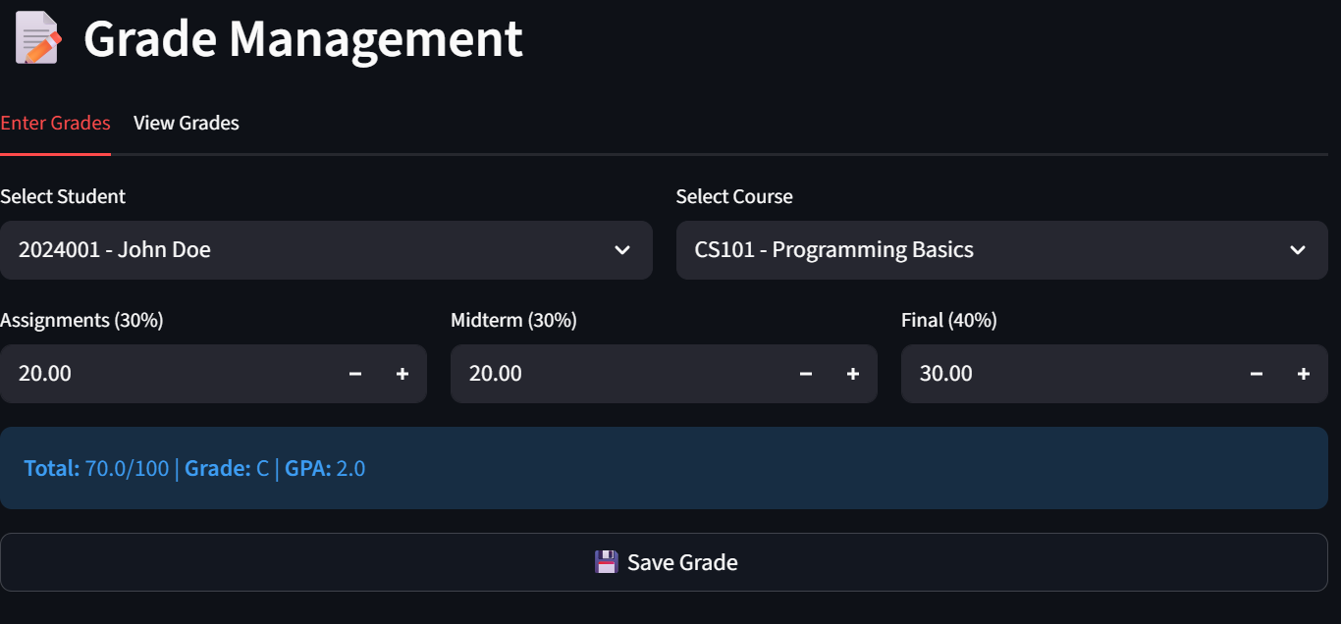

IMPLEMENTATION – ADVANCED FEATURES:

SEARCH FUNCTIONALITY
• Student search by name/roll
• Course search by code/name
• Grade filtering
• Attendance query system

DATA VALIDATION
• Input format checking
• Duplicate prevention
• Range validation
• Error handling

REPORTING SYSTEM
• Student performance reports
• Course statistics
• Grade distribution charts
• Attendance analytics
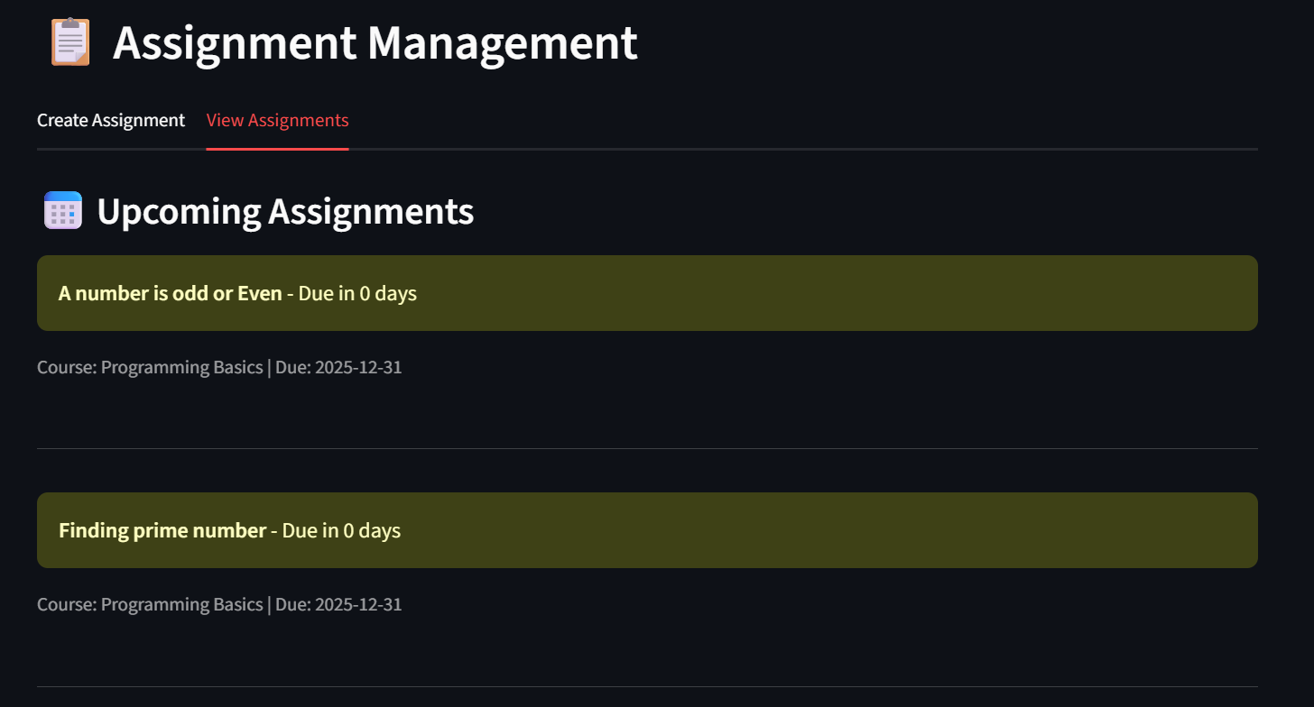
TESTING & VALIDATION:
TESTING METHODOLOGY
• Unit Testing of functions
• Integration Testing of modules
• User Acceptance Testing
• Data Validation Testing

TEST CASES
1. Add Student → Verify data saved correctly
2. Enter Grades → Verify GPA calculation
3. Mark Attendance → Verify statistics
4. Generate Report → Verify accuracy

• Roll number uniqueness
• Email format validation
• Grade range validation (0-100)
• Date format verification
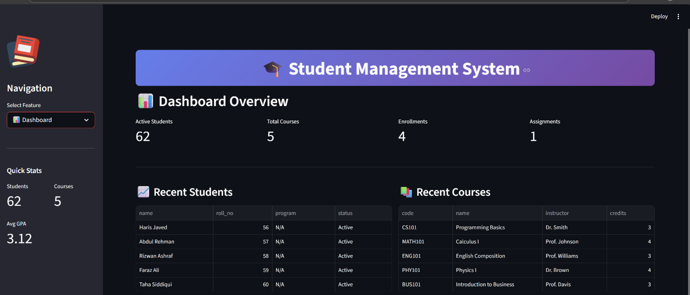

SCREENSHOTS & DEMO WALKTHROUGH:
1. DASHBOARD
- System overview
- Quick statistics
- Recent activity
2. STUDENT MANAGEMENT
- Profile creation
- Data editing
- Search functionality
3. GRADE ENTRY
- Marks input
- Grade calculation
- GPA computation
4. REPORTS
- Performance analytics
- Visual charts
- Export options

CONCLUSION & FUTURE WORK:
IMPLEMENTATION SUMMARY
• Successfully developed working SIMS prototype
• All core features implemented
• User-friendly web interface
• Robust data management

CHALLENGES FACED
• Data synchronization issues
• Error handling implementation
• Performance optimization
• User interface design

FUTURE ENHANCEMENTS
1. Mobile Application Development
2. Cloud Storage Integration
3. AI-based Analytics
4. Multi-language Support
5. Real-time Collaboration
6. Advanced Security Features

